AHSANULLAH UNIVERSITY OF SCIENCE AND TECHNOLOGY

Lab Report

DESIGNING A MINIMUM DISTANCE TO CLASS MEAN CLASSIFIER

Author: Mentor:
Saadmaan Asif Islam Hasan Mahmud
sadman0510@gmail.com

Contents
Introduction 3
Objective 3
Implementation
Plotting two class set of given prototypes 4
Classifying given points with given linear discriminant function 5
Drawing the decision boundary between two classes 7
Result Analysis 8
Conclusion 10

INTRODUCTION
The minimum distance technique uses the mean vectors of each endmember and calculates the Euclidean distance from each unknown pixel to the mean vector for each class. All pixels are classified to the nearest class unless a standard deviation or distance threshold is specified, in which case some pixels may be unclassified if they do not meet the selected criteria.
The decision boundary separates each class from another. Minimum distance to class mean classifier is a linear classifier. So this algorithm fails to classify all samples correctly because of its linear property. When many samples is taken and they are scattered in feature space then linear decision boundary is unable to classify all of them.

OBJECTIVE
Given the following two-class set of prototypes
ω1 = {(2,2), (3,1), (3,3), (-1, -3), (4,2), (-2, -2)}
ω2 = {(0,0), (-2,2), (-1, -1), (-4, 2), (-4, 3), (2, 6)}

1. Plot all sample points from both classes, but samples from the same class should have the same color and marker.
2. Using a minimum distance classifier with respect to ‘class mean’, classify the following points by plotting them with the designated class-color but different marker.
X1 = (-1,-1)
X2 = (3, 2)
X3 = (-2, 1)
X4 = (8, 2)
Linear Discriminant Function:
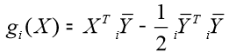
3. Draw the decision boundary between the two-classes

IMPLEMENTATION
- Plotting two-class set of prototypes
Two classes in each dataset were given. Firstly, I plotted all the points. Samples from the same class were plotted using the same color and marker so that different classes can be distinguished easily. Here cyan square to represent class1 and green square to represent class2.
MATLAB CODE
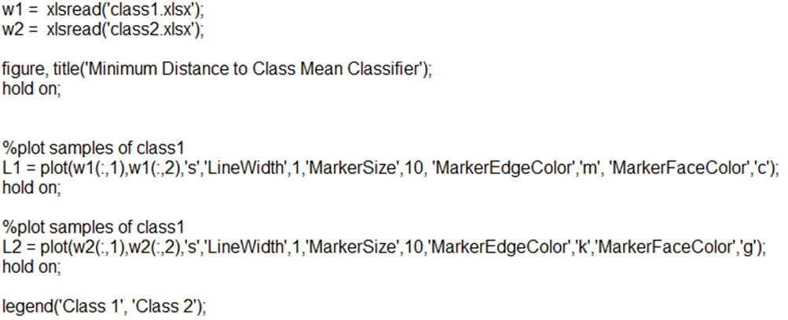
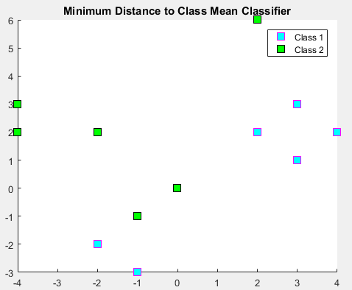
Figure 1: Output after running Matlab code 1.1
- Classifying given points with given linear discriminant function with designated class color but different marker
The mean points of the two classes are calculated & plotted with same class color with the diamond marker (blue for class 1 & red for class 2).

MATLAB CODE
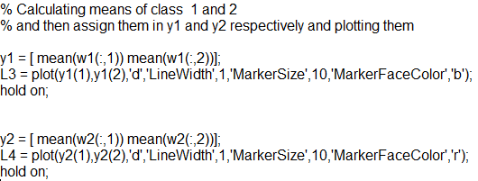

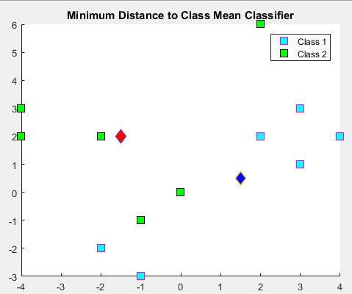
Figure 2: Output after running Matlab code 1.2
Now for each of the point (X1…X4), I calculated the distance from the mean of each class using linear discriminant function:
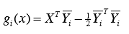
I used the discriminant function in the form:
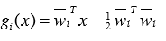
so, for the two classes (w1, w2) the function becomes,
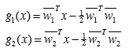
The points were assigned to the class with minimum distance from the respected class mean. I used the same class color but different marker while plotting those points. Here the star * are the given test samples (‘*’ for class 1 & ‘o’ for class 2).

MATLAB CODE
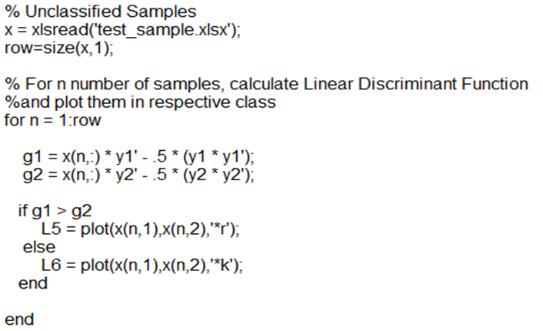
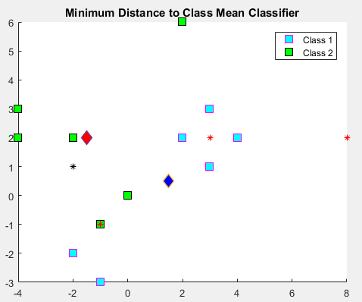
Figure 3: Output after running Matlab code 1.3

- Drawing the decision boundary between the two-classes
Decision boundary between the two classes is to be drawn now. For ﬁnding out this boundary I considered all possible points within the range considering those points as over the boundary line whose distance from both the classes is same. However, I used minimum & maximum values of x1 to calculate x2 using the following function for the approximate boundary between the two classes. Here ‘--’ line represents the linear decision boundary between the two classes.
MATLAB CODE
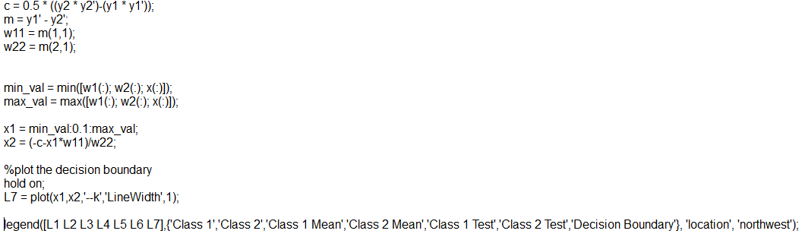
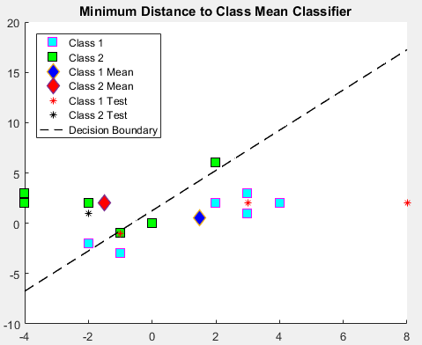
Figure 4: Output after running Matlab code 1.4

RESULT ANALYSIS
So, from the above example we can see that 1 sample of class1 and 1 sample of class2 are misclassified. But all the 4 test samples are correctly classified. So accuracy of this example is 81.25%.
As minimum distance to mean classifier is a linear classiﬁer, if the sample points of each class are uniformly distributed/scattered in the feature space it can’t classify all in correct manner. The classiﬁer will give good result if the sample points of one class is far from the other.

Now we will see another dataset to check how much accuracy the linear decision boundary can give for more sample points in the feature space.

Another Dataset 2
w1 = {(2 -1), (3 0), (3 2), (-1-3), (4 1), (-2 -4), (0 -1), (-2 2), (-1 -4), (-4 1)}
w2 = {(0 0), (-2 1), (-1 -1), (-4 4), (-4 1), (2 6), (2 2), (3 1), (3 -1), (-1 -3)}
Sample points,
X1 = (5 2)
X2 = (2 -4)
X3 = (-1 8)
X4 = (-2 -3)
X5 = (-2 -12)
X6 = (-10 6)
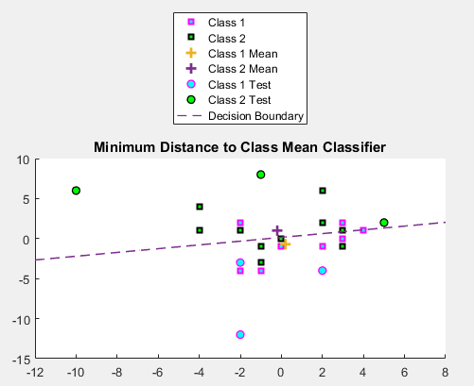
Figure 5: Output for dataset2
So, from the above example we can see that 2 sample of class1 and 4 sample of class2 are misclassified. But all the 4 test samples are correctly classified. So accuracy of this example is 76.92%.

After analyzing 2 results we can say that, the more sample points are plotted in feature space, the chance of getting accurate result will less.

CONCLUSION
The minimum distance to class mean classify is a simple classiﬁer uses very simple calculations which is very easy to implement. However the misclassiﬁcation rate of this classiﬁer is relatively higher since the decision boundary is linear.

